**God’s personal name**

**Reading: Exodus 3:1-4,14-15a**

Moses saw a bush that was burning without being destroyed. So he decided to go closer to the bush to see how a bush could continue burning without being burned up.

The Lord saw Moses was coming to look at the bush. So he called to him from the bush. He said, “Moses, Moses!”

Moses said, “Yes Lord”

Then God said to Moses, “Tell them, I AM WHO I AM. When you go the Israelites tell them I AM sent me to you.

Then God said to Moses, “This is what you should tell the people. YAHWEH is the God of your ancestors, the God of Abraham, the God of Isaac and the God of Jacob. My name will always be YAHWEH.”

**Thought about the reading**

Our queen has lots of titles, like Head of the Commonwealth and Defender of the Faith. But her personal name is Elizabeth.

God also has lots of titles or names that describe who he is. But he also has a personal name.

In the reading today he tells Moses his personal name. Moses was an important person in the Old Testament. With God’s help he led the people of Israel out of Egypt where they were slaves.

God’s personal name is Yahweh or I AM. This means that God has always been alive. He has no beginning or end. He lives forever and is always with us.

God has told us his name, and he knows our names too. He calls us by name because he loves each one of us.

**Prayer**

Yahweh, we praise you because you are the mighty God who lives forever.

Thank you that you have told us your personal name.

Thank you that you know my name and you love me.

Amen

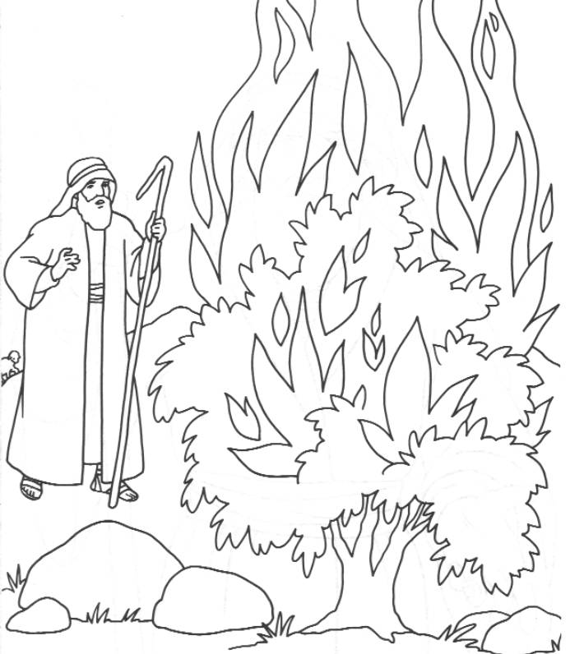

**Cambridge Causeway**

Spring 2022

Bible Study notes

**Names of God**

**2. God’s personal name**

By Chrissy Cole